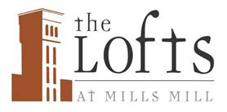

**Glass Recycling Returns to the Lofts at Mills Mill**

Beginning the week of April 22nd 2019, the residents of the Lofts will be able to recycle glass bottles and jars. Two Recycling Containers will be placed in the current recycling area. These will be labeled for Glass Recycling only.

Our program with RAM is for *Glass Bottles and Jars only*. Please do not place ceramics, window glass or any other product in these containers.

With the ability to recycle our glass bottles and jars, we ask all residents to stop placing these items in the trash chutes. Removing glass from the waste stream will help clean up our trash and eliminate the broken glass that ends up spilling from trash bins and trucks onto our lawns and parking lot.