CREEKWOOD
Architectural Control Committee Guidelines

Purpose
These guidelines have been established in order to maintain and improve the character and visual environment within Creekwood.

Failure to submit the required information or failure to comply with these guidelines shall result in immediate action by the Board. The ACC has exclusive jurisdiction over all construction, alterations or additions on any portion of the property and may charge reasonable fees for review of applications if the application requires review by Architects, engineers or other professionals.

Submittals

- Submittals must be in writing. No verbal submittals will be considered. Submittals should be sent to cbolick@nhe-inc.com with a CC to: creekwood.creekwood@gmail.com

- The board will review and circulate each request to the Architectural Control committee members for final review and approval. Rulings are usually reached in less than 2 weeks. However, requests that are more complicated, controversial or are missing detail may take longer. The committee will meet on an “as needed” basis.

- Submittals must include:
  - Creekwood submittal form – A copy of this form is attached to the end of these guidelines and additional copies may be obtained from the Board or Cathy Bolick upon request.

  - Site Plan – the site plan should indicate the address and the lot number, the position of any existing structures, the location of any utility or drainage easements that affect the property and the area of the proposed work. The survey plat provided to you at closing is a good starting point.

  - Sketch — The sketch should illustrate the proposed improvement and should include appropriate notation/description for clarification of the proposed ideas. If a photograph or brochure of the product to be used is available, this should be included with the sketch.

  - Homeowners will be notified in writing within 3 business days after the Committee votes.

  - There is a time frame of 4 months to complete the project. If it is after the 4 month deadline you will need to resubmit your request for a new approval.

Fencing Guidelines

All fences require ACC approval.

- Fence Placement
  - Structural support side of the fence shall face the enclosed area.
  - Fencing shall not be forward of 50% of the depth main structure.
  - It is acceptable to add a small fence section to shield AC units from street view.
  - Fencing alongside yards may be shared if the following criteria is met:
    - The shared section of fencing cannot be erected directly on the property line; it must fall into one of the lots.
    - Both Homeowners to be sharing the fence must be in agreement with one another.
  - Fencing must not encroach any drainage or utility easement. (Refer to Article IV Easements over property for Covenants and Restrictions.) Any fencing placed on an easement will be removed in the case that the fencing obstructs necessary maintenance.

- Fence Types
- No chain link fences or pet enclosures.
- No split rail fences.
- Wooden fences must be stained or painted in natural, earth tone colors. Colors must be approved by the ACC.
- Fences must be no taller than 6', measured at the post, not including decorative caps. The top edge of the fencing shall not deviate more than 6" from the top of the posts, not including decorative caps.
- The examples in Appendix A illustrate the fence types approved for Creekwood. Other types of fencing may be allowed with ACC approval.

Landscaping Guidelines

Major landscaping plans should be approved by the ACC. Minor landscaping, that meets the guidelines below, does not require ACC approval.

Placement of landscaping beds and materials on or over utility structures including storm drains, electrical transformers, meters, streetlights, mailboxes, etc., is not allowed. No planting is allowed within a utility or drainage easement.

- Borders for Landscaping Beds
- Materials must be natural with natural earth tone colors
- Approved materials include the following:
    - Brown or gray stone
    - Wooden timbers
    - Solid brick (Match brick of structure)
    - Concrete pavers

- Mulch Material
Approved materials include the following:
- Wood mulch
- Pine straw

- Plant Material
- Any plant that can naturally thrive in upstate South Carolina
- Recommendation: Plant materials be indigenous to upstate South Carolina
- Vegetable gardens must be located in rear yard area and screened from the street.

- Decorative Sculpture
Any Sculptures, statues, bird feeders, windmills, etc., in front yard areas must be approved before installation. Other such sculpture shall be located in the rear yard and shall be screened from the street and should not be visible to other neighbors.

Outbuilding Guidelines

All outbuildings require ACC approval.

In order to comply with the Covenants, outbuildings must be permanent structures that meet the following guidelines:

- Satisfy Greenville County code requirements.
- Require a Greenville County building permit.
- Built on a foundation.
- The lot layout favors placement of the building. (ie., corner lots are typically not candidates.)
- Siding, roofing, and windows match the house.
- Maximum size is 12' x 20'.
- Building height shall be no more than 1 story.
- Roof shall be pitched similar to the house. No flat roofs are allowed.
- Plastic storage shed are not permitted.

Basketball Backboards

In order to comply with the Covenants, basketball backboards are allowed under the following guidelines:

“Section 2. Prohibited Activities. No noxious, offensive or unkempt activity shall be conducted on any Lot. Each owner of any Lot, his family, tenants, guests and invintees, shall reframe from any act or use of his property which could reasonably cause embarrassment, discomfort, annoyance or nuisance to any other resident or residents of any other Lot. Storage or placement of furniture, fixtures, appliances, machinery, bicycles, towels, equipment or other goods or chattels not in active use on any Lot which is visible from outside the Lot (including rooftop terraces) is prohibited except as specially permitted in this Declaration.”

- An ACC form must be submitted prior to obtaining a Basketball Backboard
- Basketball Goal must remain on Home Owners property and may not be on the road, sidewalk or culvert
- Play is permitted on street as long as traffic is not impeded and goal is stored when play is complete
- Basketball Backboards may be stored at the side of the garage.

Satellite Dish Placement Guidelines

Satellite dishes do not require ACC approval. However, the guidelines below should be followed.
Antennas/Satellite Dishes should be selected and located, to the extent possible, to minimize their appearance from the street and neighboring properties. The location should take advantage of screening provided by existing structures and vegetation. In accordance with the Telecommunications Act of 1996 (Act), antennas and satellite dishes no larger than one meter (39") are permitted as a matter-of-right. No application is required for the installation of an antenna or satellite dish that does not exceed one meter (39") and meets the following guidelines and all Federal Communications Commission (FCC) requirements under the Act.

- All Satellite Dishes must be one meter (39") or less in diameter.
- Based on the required positioning to receive transmissions, antennas/satellite dishes should be placed in an inconspicuous location. They should not be placed in areas where they would constitute a safety hazard.
- Per the Act, antenna/satellite dishes are limited to a maximum height not to exceed the roofline of the home.
- All wiring for antennas and satellite dishes must be properly secured. Wiring should be concealed.
- Satellite dish colors should remain as purchased.
- Other than the brand name, commercial advertising on the dish is prohibited.
- Landscape planting is recommended to screen a dish from street view if it is placed in a visible location on the ground.

Appendix A

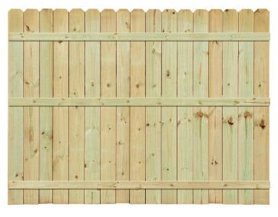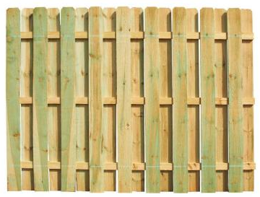

Classic Classic Shadowbox
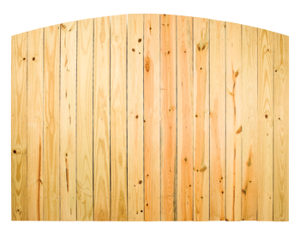
Majestic

Victorian

Majestic & Victorian can be done in shadowbox as well.

Creekwood Architectural Change Request
Homeowners Submittal Form

Homeowners Name: __________________________________________ Date:______________
Address: ________________________________________ Phone Number: ___________________
E-mail Address: ________________________________
Contractor Name:_________________________ Contractor Phone Number:____________________
Project Start Date: __________________________ Expected Completion Date*: __________________
* There is a time frame of 4 months to complete the project. If it is after the 4 month deadline you will need to resubmit your request.

Category of Improvement: (Check one)
- Addition to Primary Structure
- Auxiliary Structure
- Fencing
- Home Exterior Change / Color Change
- Landscaping / Tree Removal
- Pool
- Other

Check List:
- Written Detailed Proposal of Idea / Change
- List of Material Types To Be Used [l] Site Plan w/Easements Identified and Proposed Changes Identified
- If Fencing; Include Height, Material, Style, and Layout

Description of Proposed Changes: __________________________________________________________
___________________________________________________________________________________________________________________________________________________________________________________________________________________________________________________________________________________________________________________________________________________________________________________________________________________________________________________
Date received by A. C. C. __________Date reviewed by A. C. C. ____________Voting members _______
Approved by:____________________ Position:__________________ Signature:_____________________
Please note that after the project has been approved you will be notified by either email or phone by the representative of both the ACC Committee and the Board or Directors. This person's responsibility is to inspect the project twice (once mid way through and then upon completion of the project) to ensure that everything was done according to the approved plans. He then reports back to the board and informs them that the project is complete and according to plan or if there is any deviation from the approved plans he will inform the board of the variances.

Submittals should be sent to cbolick@nhe-inc.com with a CC to: creekwood.creekwood@gmail.com

